Snyder County Historical Society Presents

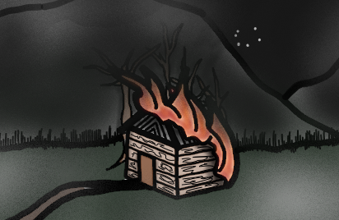

**“A Melancholy Piece of Intelligence”**

**Professor Ed Slavishak, Chair of the History Dept. Susquehanna University will focus on the Stump Massacre of 1768**

Free to the Public

Sunday June 9th 2:00 PM

Snyder County Historical Society Building

30 East Market Street Middleburg, PA

Light Refreshments to follow

[schs@snydercounty.org](mailto:schs@snydercounty.org) 570.837.6191