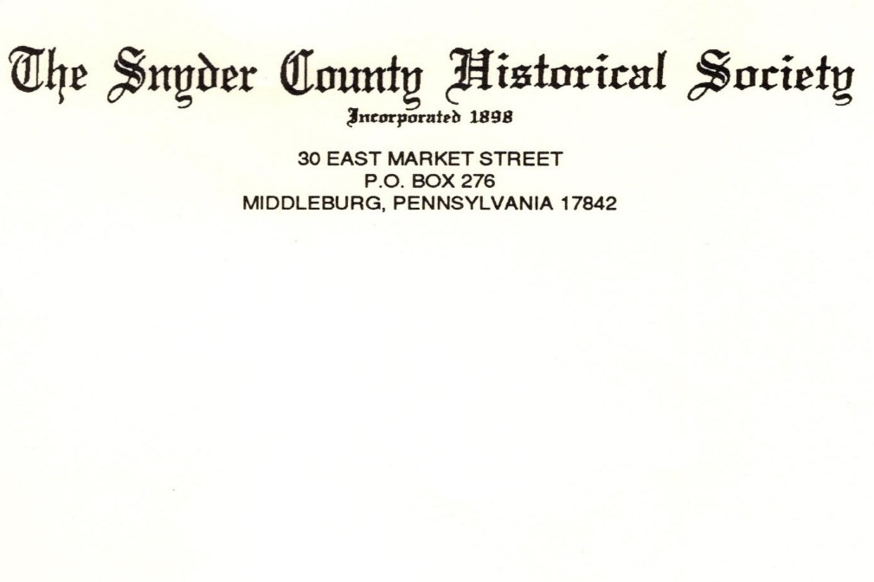
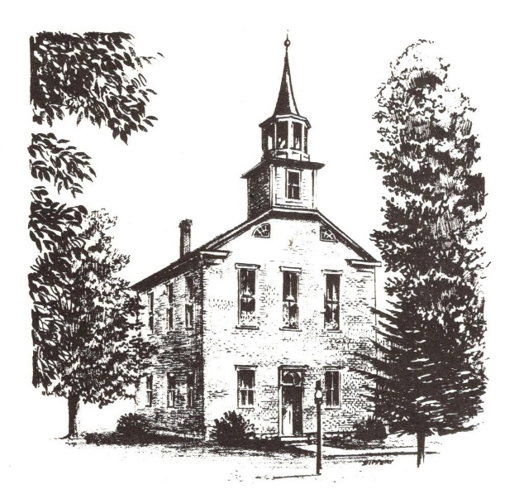
APPLICATION FOR MEMBERSHIP

Date: _____________________
Please accept my application for membership in The Snyder County Historical Society.
Amount
_________ Life Membership $300.00 (one-time payment)
_________ Individual Membership $30.00 (yearly/calendar year)
_________ Junior Individual Membership $10.00 (yearly/calendar year, till graduation)
_________ Corporate/Business Membership $500.00 (one-time payment)
_________ Contribution
_________ Memorial Gift – In memory of __________________________
_________ Total Remittance
____ Please check if renewing your membership
Name: __________________________________________________
Address:___________________________________________________
City: __________________________ State _____ Zip __________
Telephone: __________________________
Email Address: ______________________________________________
_____ Please feel free to contact me, I would be interested in volunteering time in support of The Snyder County Historical Society.
THANK YOU FOR YOUR INTEREST IN SUPPORTING AND
PRESERVING OUR SNYDER COUNTY HERITAGE

